Honor Jeffery Veterinary Physiotherapy

IMSc Veterinary Physiotherapy

Location: Wells and North Somerset

Mobile/WhatsApp: 07899333052

Email: [hjvpvetphysio@gmail.com](mailto:hjvpvetphysio@gmail.com)

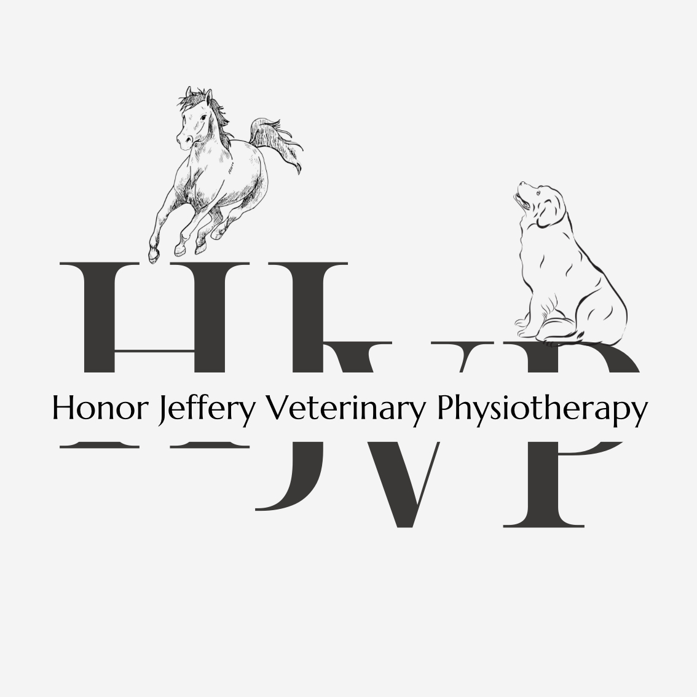

# Veterinary Consent Form:

|  |  |
| --- | --- |
| **Name:** | **Mobile:** |
| **Address:** | **Landline:** |
|  | **Email:** |

Owner information:

Animal information:

|  |  |  |  |
| --- | --- | --- | --- |
| **Animal type (horse, dog etc.):** | **Name:** | **Breed:** | **Age:** |
| **D.O.B:** | **Weight:** | **Neutered:** | **Medication:** |

*I consent for my animal to be treated by Honor Jeffery Veterinary Physiotherapy (HJVP). I agree that this animal (stated above) is mine and all of the information provided is correct.*

**Signed (In capitals with signature and date):**

Veterinary Practice and Surgeon details:

|  |  |  |
| --- | --- | --- |
| **Name of Surgeon:** |  |  |
| **Practice address:** |  |  |
| **Practice phone number:** |  |  |
| **Name of practice:** |  |  |
| **Practice email:** |  |  |

**To be completed by Veterinary Surgeon:**

Cause of concern and reason for referral to HJVP, previous medication, previous surgical intervention, precautions or contraindications and veterinary diagnosis:

*Signature of Veterinary Surgeon confirms that the animal is considered able to receive treatment from Honor Jeffery Veterinary Physiotherapy (HJVP). Please email this form back to hjvpvetphysio@gmail.com.*

**Signed (In capitals with signature and date):**